The company
Flextronics International Termelő és Szolgáltató Vámszabadterületi Korlátolt Felelősségű Társaság (hereinafter: the "Company") is domiciled at 8660 Tab, Munkás u. 28. Permanent establishments:

8900 Zalaegerszeg, Zrínyi Miklós u. 38.
8900 Zalaegerszeg, Bánki Donát út 1
8900 Zalaegerszeg, Posta u. 63.
9600 Sárvár, Ikervári u. 42.
9600 Sárvár, Ikervári u. 25.
4400 Nyíregyháza, Debreceni út 342.
1183 Budapest, Hangár u. 5-37.
2360 Gyál, Bem József u. 32.
1117 Budapest, Irinyi József u. 4-20.
9600 Sárvár, Ungvár u. 22
4400 Nyíregyháza, Debreceni út 370.
9600 Sárvár, HRSZ 1359-1360/1-1390
2360 Gyál, Gorcsev Iván utca 7. B. ép.
2225 Üllő, K-Sped körút 28.

Scope of activities:

2640 Manufacture of consumer electronics (core activity)

2611 Manufacture of electronic components
2751 Manufacture of electrical household appliances
2790 Manufacture of other electrical equipment
6820 Renting and operating of own or leased real estate
3250 Manufacture of medical devices

At the Zalaegerszeg and Tab sites the Company is primarily engaged in the production of consumer electronics, household appliances and other electrical equipment. At the Sárvár site the Company is engaged in plastic injection moulding and the production of electrical consumption products. In Sárvár, the Company also operates a central administrative and financial services unit while in Budapest it offers repair and logistics services. The Company performs R&D activities in Zalaegerszeg and Budapest.

Of one Nyíregyháza site, the lease on the property has expired, so the site is cancelled from the books, and the remaining Nyíregyháza site is used for logistical purposes.

Since 1 April 2011, the Company has been the single successor of Flextronics Budapest Kft. The merger added manufacturing and repair activities of the acquired company’s sites to the portfolio. The Company currently performs these activities at the Budapest, Üllő and Gyál sites.

Shareholders: Flextronics International GmbH (Austria, 1300 Vienna Airport, Office Park 4, Top A.54/55) holding a 99.986% quota, and Flextronics Sárvár Logistics Kft. (9600 Sárvár, Ikervári u. 25.) with participation of 0.014% (see Section 11). The ratio of ownership has been modified by the merger with Flextronics Budapest Kft. The registered capital of the acquired company had been held by Flextronics International GmbH as majority owner. The owner did not reduce the amount of share capital for the merger.

In 2013, the Company acquired 100% of the shares in RIWISA AG, Kunststoffwerke Hagglingen seated in Sonnhalde, 5607 Hagglingen, Switzerland. The Company's current name: Flex Precision Plastic Solution AG.

Flex Precision Plastic Solution AG | Balance sheet position on 31.03.2026. *
Registered capital | 3,000,000
General reserve | 1,085,000
Other reserves | 15,925,092
After-tax profit | -4,976,657
Equity | 15,033,435

* Data in the financial statements of Flex Precision Plastic Solution AG (Switzerland) are disclosed in Swiss Franc (CHF).

The Company recognised EUR 24.549.223 as long-term participation in affiliated party.

Statistical code: 11222149-2640-113-14
Company registration number: 14-09-300339

Website: www.flex.com

The consolidated financial statements of the group are consolidated into the financial statements of the parent company, Flextronics International GmbH (Austria, 1300 Vienna Airport, Office Park 4, Top A.54/55), which is consolidated into the financial statements of Flextronics International Limited (Singapore, 486123, 2 Changi South Lane, FIL). These financial statements are available at the above addresses.

Person authorised to represent Flextronics International Kft. and sign off the financial statements: Nagy László managing director (8983 Nagylengyel, Arany János utca 55.) and Christian Pfister managing director (AT-8911 Admont, Liftstrasse 528.).

Person responsible for the management and supervision of the accounting function: Tóth-Kovács Krisztina.
Registration number: 194202.

Pursuant to Section 155 of Act C of 2000, the Company is subject to mandatory audit. Independent auditor: Deloitte Könyvvizsgáló és Tanácsadó Kft. (Deloitte Auditing and Consulting Ltd.)
1068 Budapest, Dózsa György út 84/c
Chamber registration number: 000083

Registered auditor:
Pádár Péter
Chamber registration number: 007251

Auditor’s fee without VAT (27 %): EUR 482.000

accounting policy
The Company keeps its books and records in accordance with Act C of 2000 on Accounting, as amended (hereinafter: "Act"), and the accounting principles generally accepted in Hungary. The Company's accounting policy, measurement methods and procedures – together with the changes introduced in the accounting policy during the year – are as follows:

2.1. The basis of accounting
The Act entered into force on 1 January 2001. Both the attached balance sheets reflecting the financial position of the Company as of 31 March 2025 and 2026 and the income statements for the years ended on 31 March 2025 and 2026 were prepared in accordance with the provisions of the Act.

2.2. Balance sheet preparation date
The Company has determined the balance sheet preparation date as the date of the year-end closing under USGAAP (generally the 3rd or 4th working day following 31 March).

Bookkeeping currency
Pursuant to the Accounting Act, Flextronics International Kft. as a duty-free zone company established by a foreign entity was required to switch to keeping its books and records in foreign currency.

On 1 January 1999, Flextronics International Kft. designated in its Articles of Association the Euro – the common currency of the European Union, introduced on 1 January 1999 – as the official currency for its bookkeeping and reporting activities.

Intangible assets
Valuable rights are amortised on a straight-line basis over 3 years (general IT products) or over 7 years (special integrated business management software). Goodwill is recognised under intangible assets. Historical cost is defined on the basis of the actual amount paid. Extraordinary depreciation shall be recognised if the book value of goodwill remains permanently and substantially higher than its market value (expected recoverable amount) as a result of the changing of circumstances affecting expectations concerning future economic benefits).

Tangible assets
Tangible assets contributed by the shareholders are recognised at the contribution value determined upon asset valuation less accumulated depreciation. The Company records purchased or manufactured tangible assets at purchase or direct production cost. Tangible assets are depreciated over their expected useful life using the straight-line method.

Tangible assets with an individual value below thHUF 200 are recorded by the Company in one lump sum as ordinary depreciation upon commissioning (capitalisation).

Expected useful life of assets:

Description |  | Years |  | %
Buildings |  | 50 |  | 2
Structures |  | 50 / 16.6 |  | 2 / 6
Technical equipment, machinery and vehicles |  | 7 / 3 / 5 |  | 14.5 / 33 / 20
Other |  | 7 |  | 14.5

The Company, using its best estimates based on reasonable and justifiable assumptions and projections, reviewed its tangible and intangible assets in cases where certain events or changes in circumstances indicated that the further use or operation of these assets could not be ensured. As a result, the Company concluded that despite the losses it was not necessary to restate its financial statements as these assets would be used in other projects or sold to related parties at the net book value.

No residual value is recognised for tangible assets; instead, depreciation is recognized for the entire historical cost.
The reason for this is that devices used during the process of manufacturing and repair are put into operation based on the singularity of the given product. This measure is also explained by the fact that the estimated residual value would be such a small amount that would be insignificant compared to the total value of the Company's assets.

Inventories
The Company records the value of purchased inventories using the FIFO method.

Self-manufactured inventories are recorded during the year at transfer prices. Year-end measurement of self-manufactured inventories is based on post-calculations.

Inventories deemed by the Company's management to be slow-moving or obsolete were written off to their net realisable value in the respective period.

Prepayments
Under prepayments, the Company recognises expenses arising before balance sheet date but recognisable only in the next financial year, as well as income falling due in the next financial year but applying to the current one.

Accruals
Under accruals, the Company recognises income collected before balance sheet date but recognisable only in the next financial year, as well as for costs recognised before balance sheet date that will be payable from the profit of the next financial year.

Provisions
The Company recognises provisions (up to the necessary amount) from the pre-tax profit for liabilities due to third parties arising from former and pending transactions that are certain or likely to exist as of the balance sheet date but whose amount and due date are still uncertain and that have not been covered by the Company in any other way.

The Company recognises provisions (up to the amount necessary in order to determine its actual profit) from the pre-tax profit for expected, significant and recurrent future costs (in particular maintenance, reorganisation and environmental costs) that are assumed or certain to be incurred in the future but whose amount and due date is uncertain and that cannot be classified as accrued expenses.

Revenue
The consideration for the sale of purchased and self-manufactured inventories, as well as for the services provided during the business year – plus surcharges and markups, less discounts and VAT – is recognised by the Company in the period of contractual performance as net sales revenue. All items related to revenue are recognised in the appropriate period, in accordance with the principle of matching. No revenue item is recognised if its realisation is uncertain.

Format of the balance sheet and the income statement
An error is considered material if in the year when discovered during various reviews the combined amount of all misstatements (whether negative or positive) identified with respect to a given business year (separately for each year) and their effects – whether increasing or reducing the profit/loss or equity – exceed 2 (two) per cent of the balance sheet total.

2.12. Material misstatements

An error is considered material if in the year when discovered during various reviews the combined amount of all misstatements (whether negative or positive) identified with respect to a given business year (separately for each year) and their effects – whether increasing or reducing the profit/loss or equity – exceed 2 (two) per cent of the balance sheet total.
Where a material misstatement is identified, the Company's financial statements are prepared using three columns.

Financial position and liquidity
The Company's financial position and liquidity as of 31 March 2025 and 2026 are illustrated by the following indicators, cash flow statement and profitability indicators.

Financial indicators:

 |  | 31 March 2025 |  | 31 March 2026
Liquidity ratio = ((current assets + prepayments) / (current liabilities + accruals)) = |  | 1.27 |  | 1.26
Quick ratio = ((current assets - inventories + prepayments)/ (current liabilities + accrued expenses)) = |  | 0.97 |  | 0.96
Debtor days on sales (accounts receivable / sales revenue x 365 days) = |  | 39 |  | 42

Cash Flow Statement
 |  | 2025 | 2026
I. | Cash flows from ordinary activities (1-13) | 73,515,227 | 43,516,937
1.a | Pre-tax profit | 8,182,380 | 17,110,009
1.b | Adjustments to pre-tax profit
 | Unrealised exchange rate difference on issued bonds | -3,815,592 | 10,349,956
 | Unrealised exchange rate difference on loans given | 3,815,592 | -10,349,956
 | Capitalised interest
 | Dividend received
 | Non-repayable funds transferred/received for development purposes
 | Non-repayable assets transferred/received
 | Year-end revaluation difference of forex cash and bank balances
2 | Amortisation and depreciation recognised | 28,734,033 | 27,211,162
3 | Impairment recognised and reversed (-) | 7,180,880 | 394,831
4 | Difference between provisions made and used | -4,096,560 | -221,109
5 | Profit on disposals of fixed assets | 1,083,328 | 180,617
6 | Change in trade payables | -117,567,651 | 19,688,591
7 | Change in other short-term liabilities | -14,078,959 | -7,814,085
8 | Change in accruals | -3,131,597 | 20,549,660
9 | Change in trade receivables | 137,404,285 | -6,560,172
10 | Change in current assets (w/o accounts receivable and cash and bank balances) | 9,210,913 | -8,585,575
11 | Change in prepayments | 20,676,167 | -18,032,316
12 | Taxes paid, payable on profit | -81,992 | -404,676
13 | Dividend and profit sharing paid and payable
II. | Cash flows from investing activities (14-18) | -43,797,349 | -42,764,165
14 | Purchase of fixed assets | -46,625,157 | -43,292,692
15 | Sale of fixed assets | 1,509,549 | 528,527
16 | Repayment, termination and conversion of long-term loans given and bank deposits | 1,318,259 | 0
17 | Long-term loans granted and long-term bank deposits | 0 | 0
18 | Dividend and profit sharing received | 0 | 0
III. | Cash flows from financing activities (19-29) | -29,678,051 | 0
19 | Proceeds from the issue of shares and capital increase | 0 | 0
20 | Proceeds from the issue of bonds and debentures | 0 | 0
21 | Loans and borrowings received | 0 | 0
22 | Non-repayable funds received | 0 | 0
23 | Non-repayable funds received | 0 | 0
24 | Non-repayable funds received | 0 | 0
25 | Repayment of loans and borrowings | -29,678,051 | 0
26 | Non-repayable funds transferred | 0 | 0
IV. | Changes in cash and bank accounts (I.+II. +III.) | 39,827 | 752,772
27 | Revaluation of cash and cash equivalents denominated in foreign currency | 0 | 0
V. | Change in cash from balance sheet (IV. +27.) | 39,827 | 752,772
 | Opening balance | 1,341,435 | 1,381,262
 | Closing balance | 1,381,262 | 2,134,034

Profitability indicators:

 | 31 March 2025 |  | 31 March 2026
Turnover of assets (Revenue / Assets) | 1.29 |  | 1.15
Operating margin (Operating profit / Revenue) | 0.01 |  | 0.00

Intangible and tangible assets

Change in intangible and tangible assets in the fiscal year ended on 31 March 2026:

 | Valuable rights | Land and buildings | Production machinery | Other equipment | Capital expenditure | Prepayments on capital expenditure | Total
Gross Value
Opening balance as of 31.03.2025 | 3,032,390 | 73,014,063 | 224,401,715 | 38,093,936 | 30,767,643 | 3,605,298 | 372,915,045
Capitalisation | 1,698 | 23,809,792 | 6,679,309 | 5,811,248 | (36,302,047) | 0 | 0
Increase | 0 | 0 | 752,332 | 28,411 | 39,106,630 | 6,078,990 | 45,966,363
Disposals and other decrease | (16,900) | (2,534) | (5,395,043) | (414,664) | 0 | (3,605,298) | (9,434,439)
Reclassification | 0 | 0 | 0 | 0 | (66,104) | 0 | (66,104)
Other | 0 | 0 | 132,870 | 9,614 | 0 | 0 | 142,484
Closing balance at 31.03.2026 | 3,017,188 | 96,821,321 | 226,571,183 | 43,528,545 | 33,506,122 | 6,078,990 | 409,523,349
Accumulated depreciation
Opening balance as of 31.03.2025 | 2,932,402 | 32,706,110 | 157,627,989 | 32,033,816 | 0 | 0 | 225,300,317
Disposals and other decrease | (16,900) | (2,534) | (4,943,656) | (414,663) | 0 | 0 | (5,377,753)
Depreciation recognised | 63,200 | 3,981,227 | 20,456,567 | 2,710,168 | 0 | 0 | 27,211,162
Reclassification | 0 | 0 | 158,015 | 53 | 0 | 0 | 158,068
Other | 0 | 0 | 166,454 | 9,614 | 0 | 0 | 176,068
Closing balance at 31.03.2026 | 2,978,702 | 36,684,803 | 173,465,369 | 34,338,988 | 0 | 0 | 247,467,862
Net value | 38,486 | 60,136,518 | 53,105,814 | 9,189,557 | 33,506,122 | 6,078,990 | 162,055,487

The movement table of tangible assets does not contain assets of small value, the total value of which was EUR 309.700 for the business year 2026. Main part of the increase in the balance of assets is due to the expansion of manufacturing capacity and the construction of the "Next Gen Mobility" plant in the automotive business.

INVESTMENTS

 | 31 March 2025 |  | 31 March 2026
Long-term shares in affiliated parties | 23,617,596 |  | 24,549,223

In 2013, the Company acquired 100% of the shares in RIWISA AG, Kunststoffwerke Hagglingen, headquartered in Sonnhalde, 5607 Hagglingen, Switzerland. The Company's current name is Flex Precision Plastic Solution AG. In relation to the investment, the Company recognises EUR 24,549,223 as long-term shares in affiliated parties. The increase is attributable to the foreign exchange revaluation recognised during the financial year.

The most significant change in the subsidiary's performance during the current financial year was the discontinuation of the former Nespresso production volumes, which negatively impacted manufacturing utilisation in the short term and resulted in the recognition of unabsorbed costs within the cost structure. At the same time, several new Medical business programmes are currently in the ramp-up phase, which are expected to support future growth and improvements in operating profit.
Revenue for the current financial year remained in line with previous expectations without any significant decline. Current forecasts for the coming years indicate meaningful volume and revenue growth, with the newly launched business programmes expected to contribute increasingly to overall sales levels.

The Company provided a long-term loan to its parent company, Flex Ltd, in December 2021 with a ten-year term. The outstanding loan amount is EUR 259.168.070

IMPAIRMENT OF INVENTORIES
 |  | 31 March 2025 |  | 31 March 2026
Opening impairment |  | 8,737,646 |  | 3,325,392
Impairment recognised |  | 3,325,392 |  | 3,825,272
Reversed impairment |  | -8,737,646 |  | -3,325,392
Closing impairment |  | 3,325,392 |  | 3,825,272

MATERIALS

The break-down of materials is the following:

 |  | 31 March 2025 |  | 31 March 2026
Raw materials |  | 105,549,946 |  | 149,936,863
Inventories in transit |  | 29,585,892 |  | 18,002,698
Non-serial material |  | 85 |  | 85
Total |  | 135,135,923 |  | 167,939,646

The average turnover of inventories was 44 days in 2025 and 48 days in 2026

change in self-manufactured inventories
Opening balance 31 March 2025 |  | 54,431,789
Closing balance 31 March 2026 |  | 29,525,146
Change in self-manufactured inventories |  | -24,906,643

receivables
Receivables were as follows:
 | 31 March 2025 |  | 31 March 2026
Trade receivables | 171,836,314 |  | 173,105,117
Gross value | 172,281,552 |  | 173,353,499
Impairment | 445,238 |  | 248,382
Receivables from other Flextronics affiliates | 404,433,674 |  | 409,830,087
Flextronics International Singapore PTE Ltd., Singapore | 241,615,065 |  | 228,424,430
Flextronics International SPA, Italy | 30,497,805 |  | 47,765,254
Flextronics International Mexico | 47,874,838 |  | 42,256,954
Flextronics International Ltd., Ireland | 12,773,302 |  | 26,507,675
Flextronics International Netherlands | 20,715,464 |  | 21,146,717
Other Flextronics companies | 23,665,140 |  | 16,345,224
Flextronics International Israel Ltd., Israel | 12,190,306 |  | 10,943,734
Flextronics International Great Britain | 5,177,725 |  | 6,014,389
Flextronics International Poland, Poland | 310,232 |  | 2,349,441
Flextronics International GmbH., Austria | 2,954,738 |  | 2,186,786
Flextronics International Ltd., USA | 1,740,921 |  | 2,087,894
Flextronics International Malaysia SDN.BHD. | 2,016,582 |  | 1,303,158
Flextronics International Switzerland | 1,142,218 |  | 1,257,433
Flextronics International Denmark, Denmark | 392,381 |  | 568,255
Flextronics Design S.R.O., Czech Republic | 364,927 |  | 356,214
Flextronics Industrial Technology Ltd., China | 425,572 |  | 167,409
Flextronics International Sweden AB, Sweden | 44,957 |  | 59,984
Flextronics International Germany, Germany | -3,786 |  | 33,410
Flextronics International France | 17,568 |  | 21,535
Flextronics International India | 6,345 |  | 14,714
Flextronics International Technology Ltd., Brazil | 174,045 |  | 10,507
Flextronics Magyarország | 337,329 |  | 8,970
Flextronics International Finland | 0 |  | 0

CHANGES IN IMPAIRMENT
Opening impairment as of 31 March 2025 | 445,238
Addition | 248,382
Write-back | -445,238
Closing balance as of 31 March 2026 | 248,382

 | 31 March 2025 |  | 31 March 2026
Other receivables | 4,168,769 |  | 2,568,669
Value added tax | 2,827,547 |  | 1,503,799
Corporate income tax | 0 |  | 0
Foreign VAT | 185,378 |  | 153,710
Receivables due from employees | 387,637 |  | 848,107
Other | 68,810 |  | 6,435
Other NAV receivables | 0 |  | 0
Self-revision fees | 0 |  | 0
Environmental product charge | 0 |  | 0
Local tax authority payables/receivables | 699,397 |  | 56,618
Total | 580,438,757 |  | 585,503,873

bank deposits
The Company's bank deposits in EUR were as follows:

 |  | 31 March 2025 |  | 31 March 2026
CHF bank deposits |  | 604,453 |  | 506,462
EUR bank deposits |  | 530,684 |  | 22,606
HUF bank deposits |  | 244,760 |  | 493,649
USD bank deposits |  | 0 |  | 1,110,576
Total |  | 1,379,897 |  | 2,133,293

Prepayments
Prepayments were as follows:

 | 31 March 2025 |  | 31 March 2026
Accrued income | 31,789,408 |  | 43,130,030
Revenue from the sale of goods | 17,986,880 |  | 22,803,136
Exchange rate gain on futures transactions | 3,908,181 |  | 5,078,070
Customer incentive pricing accrual | 0 |  | 3,738,376
Recharge of project costs | 2,867,024 |  | 3,548,456
Rechargeable tools expenses | 3,117,304 |  | 3,319,491
Cost recharge to affiliated party | 2,377,965 |  | 3,022,137
Rechargeable freight costs | 978,445 |  | 1,298,932
Price difference (to charge to customers) | 6,949 |  | 259,545
Rechargeable material costs | 38,659 |  | 54,018
Other | 508,001 |  | 7,869
Prepaid expenses | 15,163,682 |  | 21,855,376
Project costs | 9,165,770 |  | 17,053,668
Accrued transfer pricing compensation | 3,306,547 |  | 2,503,570
Lease | 1,229,418 |  | 1,204,821
Material costs | 736,703 |  | 548,318
Other | 391,891 |  | 239,168
Insurance premium | 131,495 |  | 133,854
Public utility charges | 164,249 |  | 107,925
Price difference | 37,609 |  | 64,052
Total | 46,953,090 |  | 64,985,406

eQUITY
The summary of the registered capital is as follows:

Shareholder | Initial contribution |  |  | Business share
 | 31 March 2025 | 31 March 2026 |  | 31 March 2025 | 31 March 2026
Flextronics International GmbH, Bécs | 5,590,032 | 5,590,032 |  | 99.99% | 99.99%
Flextronics Sárvár Logistics Kft. | 783 | 783 |  | 0.01% | 0.01%
Total | 5,590,815 | 5,590,815 |  | 100% | 100%

 | Registered capital | Capital reserve* | Profit reserve | Tied-up reserve | After-tax profit | Equity
Balance as of 31 March 2025 | 5,590,815 | 61,635,219 | 153,742,267 | 108,779,860 | 8,100,388 | 337,848,549
Reclassification of the 2025 profit |  |  | 8,100,388 |  | -8,100,388 | 0
Adjusting items |  |  |  |  |  | 0
Profit for the year ended 31 March 2026 |  |  |  |  | 16,705,333 | 16,705,333
Balance as of 31 March 2026 | 5,590,815 | 61,635,219 | 161,842,655 | 108,779,860 | 16,705,333 | 354,553,882

* The Company's capital reserve of EUR 61,635,219 comprises the following elements:
- EUR 490,339 amount above the registered capital generated in the conversion to HUF of foreign exchange paid as capital increase in 1994
- EUR 448,874 gain generated in the transition from HUF to EUR as of 1 January 1999
- as of 1 October 2002, under the amending resolution of the memorandum and articles of association No. 15/2002 an amount of EUR 59,889,689 was reclassified to the capital reserve from the profit reserve.
- as of 1 April 2011, Flextronics Budapest Kft merged into the Company; as a result of this in the balance sheet after the merger part of the negative accumulated profit reserve was offset with the capital reserve; the remaining capital reserve was recognized as an addition in the amount of EUR 806,317
Based on our proposal, no dividends are paid from the 2026 profit.

PROVISIONS
Provisions were as follows as of 31 March 2025 and 2026:

 | 31 March 2025 |  | 31 March 2026
Provisions for expected liabilities
For warranty obligations | 1,885,190 |  | 3,737,889
For severance pay, unused leave | 3,078,686 |  | 1,498,322
Other | 1,129,587 |  | 636,143
Total | 6,093,463 |  | 5,872,354

PROVISIONS MOVEMENT TABLE

Legal grounds | 31 March 2025 | Charge | Release | 31 March 2026
For warranty obligations | 1,885,190 | 1,569,730 | 1,885,190 | 1,569,730
For severance pay, unused leave | 3,078,686 | 3,653,490 | 3,078,686 | 3,653,490
For deductions | 74,939 | 76,585 | 74,939 | 76,585
Waste management | 63,504 | 69,453 | 63,504 | 69,453
Other | 624,399 | 0 | 351,760 | 272,639
Provisions for future liabilities | 366,745 | 230,457 | 366,745 | 230,457
Total | 6,093,463 | 5,599,715 | 5,820,824 | 5,872,354

The amount of guaranteed obligations was determined by the Company based on the warranty period on products manufactured by the Company.

LONG-TERM LIABILITIES
In December 2021, the Company issued 2,000 bonds with a nominal value of HUF 50,000,000 each, representing a total nominal value of HUF 100,000,000,000, with a ten-year maturity. The carrying amount of the bonds recognised in the balance sheet is EUR 259,168,070.

short-term borrowings
As a participant in the international group level “notional cash pool” program, our company had an overdraft facility in previous years, but this was terminated during the year 2025, so as of 31 March 2026, the company has no overdraft debt.

short-term liabilities due to affiliated parties

Breakdown of short-term liabilities to affiliated parties:
 | 31 March 2025 |  | 31 March 2026
Flextronics International GmbH., Austria | 86,295,594 |  | 117,966,593
Flextronics International Europe B.V., The Netherlands | 109,629,516 |  | 114,569,049
Flextronics International Italy | 56,882,165 |  | 58,515,426
Flextronics Industrial Technology Ltd., China | 5,189,205 |  | 16,349,623
Flextronics Magyarország | 9,997,500 |  | 10,375,956
Other concerns | 4,743,364 |  | 3,901,494
Flextronics International Ltd., USA | 2,524,722 |  | 3,387,196
Flextronics Int. Latin America (Ltd.), Mexico | 570,576 |  | 1,647,154
Flextronics International Germany, Germany | 4,963,399 |  | 1,475,748
Flextronics International Israel | 385,770 |  | 494,560
Flextronics International Technologia Ltda., Brazil | 169,656 |  | 320,684
Flextronics International Singapore PTE Ltd., Singapore | 316,978 |  | 245,650
Flextronics International Poland, Poland | 365,986 |  | 233,687
Flextronics International Ltd., Ireland | 17,057,512 |  | 202,534
Flextronics International Scotland, Great Britain | 158,597 |  | 191,531
Flextronics International Switzerland | 28,343 |  | 138,671
Flextronics International India | 3,728 |  | 13,455
Flextronics Ind. Malaysia SDN.BHD., Malaysia | 16,562 |  | 8,090
Flextronics International Sweden AB, Sweden | 3,254 |  | 1,378
Flextronics International Norway | 619 |  | 0
Flextronics Romania SRL | 491 |  | 0
Flextronics International France SA, France | 0 |  | 0
Total | 299,303,537 |  | 330,038,479

other short-term liabilities
Other short-term liabilities are as follows:

 | 31 March 2025 |  | 31 March 2026
Liabilities to employees | 6,772,247 |  | 0
Health insurance liability | 1,454,153 |  | 0
Personal income tax | 1,537,747 |  | 79,320
National Health Care Fund | 1,194,353 |  | 26,424
Liabilities to the local tax authority | 0 |  | 0
Rehabilitation contribution | 382,298 |  | 0
Pension insurance liability (private and voluntary) | 193,646 |  | 5
Other settlements with the central budget | 415,599 |  | 629,237
Vocational training contribution | 0 |  | 0
Liabilities related to the financing of base materials | 9,700,851 |  | 10,651,296
Other | 1,529,793 |  | 1,556,070
Total | 23,180,687 |  | 12,942,352

ACCRUALS

Accruals in the current year:

 | 31 March 2025 |  | 31 March 2026
Prepaid income | 18,219,493 |  | 36,760,948
Deferred income of product sales | 8,288,149 |  | 17,547,399
Project in progress | 5,965,819 |  | 16,092,091
Price difference (Customer discounts) | 3,965,525 |  | 3,121,458
Accrued expenses | 80,027,865 |  | 83,553,066
APA (transfer-price adjustment) | 52,202,702 |  | 36,773,629
Accrued wages and contributions | 8,163,604 |  | 23,029,858
Exchange rate losses on forward transactions | 4,900,349 |  | 5,994,510
Royalty fee | 2,253,687 |  | 4,869,611
Accrued interests | 2,839,757 |  | 2,965,167
Operating costs | 2,410,932 |  | 2,675,601
Transport charges | 2,013,482 |  | 1,886,052
Other | 572,151 |  | 1,501,152
Price difference charges | 736,164 |  | 1,061,113
Material costs | 411,806 |  | 622,531
Environmental product charge | 466,712 |  | 504,832
Warehousing | 204,420 |  | 394,011
Audit, advisory | 389,336 |  | 352,802
Passenger transport | 670,205 |  | 344,170
Operating leases | 365,966 |  | 324,772
Education, training | 281,930 |  | 321,670
Cost recharge to affiliated party | 455,442 |  | 232,420
IT and telephone charges | 95,574 |  | 148,617
Maintenance fee | 159,128 |  | 90,259
Customs expenses | 63,870 |  | 81,106
Health care services | 82,356 |  | 47,754
Vehicle lease | 14,191 |  | 2,598
HR and business entertainment | 2,023 |  | 0
Project costs | 272,078 |  | -671,169
Deferred income | 6,083,152 |  | 4,566,156
Deferral of subsidies | 6,083,152 |  | 4,566,156
Assets received without consideration | 0 |  | 0
Total | 104,330,510 |  | 124,880,170

sales recorded in foreign currency

Sales recorded in foreign currency were as follows:

 | 31 March 2025 |  | 31 March 2026
Domestic sales | 27,382,932 |  | 27,656,369
Export sales | 1,578,491,809 |  | 1,464,492,275
Total | 1,605,874,741 |  | 1,492,148,644

Revenue from affiliated parties:

 | 31 March 2025 |  | 31 March 2026
Revenue from related parties | 353,485,578 |  | 285,042,159
Of which parent and subsidiary:
Flextronics International GmbH | 4,274,768 |  | 3,897,850
Flex Precision Plastic Solution AG | 2,254,246 |  | 2,386,739

export sales in geographical breakdown
Export sales in geographical breakdown:

 | 31 March 2025 |  | 31 March 2026
EU | 1,161,964,021 |  | 1,092,353,003
Europe, non-EU | 172,223,432 |  | 162,909,403
North America | 97,798,883 |  | 116,475,753
South America | 44,195,774 |  | 45,035,026
Asia | 100,365,090 |  | 44,599,230
Australia and Oceania | 1,057,780 |  | 2,476,697
Africa | 886,829 |  | 643,163
Total | 1,578,491,809 |  | 1,464,492,275

The following is a breakdown of export sales by products and services:

 | 31 March 2025 |  | 31 March 2026
Intra-community product supply | 1,008,924,103 |  | 967,722,975
Product exports | 266,845,098 |  | 265,277,685
Intra-community services | 149,846,568 |  | 152,286,397
Service exports | 180,258,972 |  | 106,861,587
Total | 1,605,874,741 |  | 1,492,148,644

other income
Other income:

 | 31 March 2025 |  | 31 March 2026
Provisions released | 9,917,384 |  | 5,820,824
Reversal of impairment of inventories | 8,914,606 |  | 3,433,251
Release of the deferral of grants received | 1,264,241 |  | 1,583,021
Scrap paid for by customers | 977,583 |  | 1,203,719
Rebate received under contract | 734,036 |  | 723,995
Other | 244,757 |  | 548,002
Sales of tangible assets | 2,784,682 |  | 528,527
Reversal of impairment of receivables | 902,570 |  | 353,426
Income associated with damage events | 53,202 |  | 46,976
Penalties, fines, damage events | 433,332 |  | 20,515
Amount received on written off receivables | 0 |  | 2,679
Cost compensation | 1,837 |  | 1,358
Total | 26,228,230 |  | 14,266,293

impORT purchases

The following is a breakdown by geographies of the import of products and services:

Product imports | 31 March 2025 |  | 31 March 2026
EU | 553,998,393 |  | 404,743,348
Asia | 233,386,179 |  | 286,017,407
Europe (non-EU) | 77,165,194 |  | 71,021,055
North America | 32,589,491 |  | 48,672,761
Africa | 8,080,732 |  | 4,422,184
South America | -5,890 |  | 38,163
Australia and Oceania | -13,051 |  | 63,470
Total | 905,201,048 |  | 814,978,388

Service imports | 31 March 2025 |  | 31 March 2026
EU | 240,927,760 |  | 249,841,071
NON- EU | 2,874,549 |  | 3,282,295
Total | 243,802,309 |  | 253,123,366

services used
Services used were the following:

 | 31 March 2025 |  | 31 March 2026
Services related to production | 61,995,371 |  | 32,192,987
Staff costs | 41,861,520 |  | 37,244,881
APA (transfer-price adjustment) | 52,202,702 |  | 36,773,629
Management services | 34,074,585 |  | 30,495,842
Operation and maintenance cost | 12,202,662 |  | 12,535,192
Operating lease fees | 11,836,990 |  | 12,039,617
Passenger transport | 4,781,549 |  | 4,940,587
Administrative services | 2,219,709 |  | 3,067,195
Royalty fee | 2,146,446 |  | 2,563,941
Costs of book-keeping and audit services | 1,809,816 |  | 2,055,456
Transportation, loading, warehousing | 1,571,025 |  | 973,347
Other | 1,554,663 |  | 1,590,811
Rental fees | 1,400,465 |  | 867,536
EDP/IT services | 716,551 |  | 633,436
Advertising costs (P&A) | 82,743 |  | 111,623
Total | 230,456,797 |  | 178,086,080

other services

Breakdown of other services:

 | 31 March 2025 |  | 31 March 2026
Financial and investment service fees | 471,752 |  | 584,095
Bank charges | 12,144 |  | 32,171
Insurance premium | 22 |  | 7
Administrative fees and duties | 8,703 |  | 86,270
Total | 492,621 |  | 702,543

other expenses
Other expenses were the following:

 | 31 March 2025 |  | 31 March 2026
Provisioning | 5,820,824 |  | 5,599,715
Inventory scrapping | 5,445,205 |  | 3,294,927
Impairment of inventory | 3,548,983 |  | 3,933,125
Book value of tangible assets sold | 2,433,279 |  | 442,805
Discounts given and settled | 1,122,751 |  | 1,105,218
Scrapping of tangible assets | 1,084,889 |  | 128,554
Various other expenditures | 1,046,541 |  | 1,820,961
Expenses related to warranty | 949,567 |  | 1,168,606
Impairment of trade receivables | 445,238 |  | 248,382
Credit loss | 284,307 |  | 11,287
Fine, penalty | 181,644 |  | 199,274
Payments relating to damage events | 165,419 |  | 313,000
Donations given | 20,656 |  | 45,467
Taxes | 8,891,865 |  | 9,317,348
Total | 31,441,168 |  | 27,628,669

income from financial transactions
Income from financial transactions:

 | 31 March 2025 |  | 31 March 2026
Other received interest, interest-type income | 33,243,244 |  | 25,195,155
Interest received from Flextronics companies | 33,213,423 |  | 25,149,520
Interest income ETC | 9,425 |  | 45,534
Interest income from financial institutions | 20,396 |  | 101
Other income from financial transactions | 689,291 |  | 9,639,898
Exchange rate gain on receivables and liabilities | 266,452 |  | 3,011,150
Realised capital gain on futures | 422,839 |  | 6,607,455
Unrealised capital gain on receivables and liabilities | 0 |  | 0
Income from cash discounts | 0 |  | 21,293
Total | 33,932,535 |  | 34,835,053

Expenses of financial transactions
Breakdown of expenses of financial transactions:

 | 31 March 2025 |  | 31 March 2026
Interest payable and similar expenditure | 26,327,615 |  | 18,874,761
Interest payable to financial institutions | 8,907,455 |  | 9,338,795
Interest paid to Flextronics member firms | 15,757,587 |  | 8,649,058
Loss on sale of trade receivables | 1,662,573 |  | 886,908
Lease interest | 0 |  | 0
Impairment of shares, securities, long-term loans given and bank deposits | 13,050,466 |  | -0
Other expenses of financial transactions | 1,531,647 |  | 4,351,898
Exchange rate loss on receivables and liabilities | 1,425,094 |  | 4,265,865
Realised FX loss on futures | 0 |  | 0
Unrealised exchange rate losses on receivables and liabilities | 0 |  | 0
Expenses of cash discounts | 106,553 |  | 86,033
Total | 40,909,728 |  | 23,226,659

board of directors, management, supervisory board
No payments were made to the members of the Company's Board of Directors and Supervisory Board during the business years ended 31 March 2025 and 31 March 2026.

staff
The average headcount by employee group was as follows:

 | 2025 |  | 2026
Direct | 2,831 |  | 2,550
Indirect | 2,927 |  | 2,789
Total | 5,758 |  | 5,339

Wage costs and other staff benefits paid by category:

 | Payroll costs |  | Other payments to staff |  | Total
 | 2025 | 2026 | 2025 | 2026 | 2025 | 2026
Direct | 62,136,218 | 65,100,388 | 7,037,609 | 7,633,359 | 69,173,827 | 72,733,747
Indirect | 53,718,274 | 55,684,539 | 5,418,010 | 5,480,515 | 59,136,283 | 61,165,054
Total | 115,854,492 | 120,784,927 | 12,455,619 | 13,113,874 | 128,310,110 | 133,898,801

The amount of wage contributions related to the salaries, wages and other payroll related costs:

 | 2025 |  | 2026
Direct | 11,722,796 |  | 11,670,741
Indirect | 5,977,033 |  | 6,571,109
Total | 17,699,829 |  | 18,241,850

corporate income tax
The items modifying the Company's corporate income tax base in 2026 were the following:

 | 2025 |  | 2026
Pre-tax profit | 8,182,380 |  | 17,110,008
Deductibles | 59,058,345 |  | 48,520,085
Amount recorded as income in the tax year due to the use of provisions | 9,917,384 |  | 5,820,824
Amount deducted from the previous years' deferred losses in the tax year | 911,017 |  | 4,496,404
Depreciation recognised as per the tax law | 31,025,526 |  | 28,039,958
Allowance received on students who take part in vocational training | 9,615 |  | 4,641
Exchange rate gain on the revaluation of shares | 1,052,921 |  | 931,627
Reversal of impairment recorded on receivables | 902,570 |  | 356,105
Direct costs of research and development | 15,239,313 |  | 8,870,526
Other deductibles | 0 |  | 0
Reversal of impairment of shares | 0 |  | 0
Additions | 51,786,983 |  | 35,906,481
Provisions for expected liabilities and future expenses | 5,820,824 |  | 5,599,715
Depreciation as per the Accounting Act - | 31,077,789 |  | 28,092,221
Costs not incurred in the interest of the Company | 1,351,503 |  | 1,925,919
Fine imposed by a final ruling | 41,162 |  | 28,957
Impairment of trade receivables | 445,238 |  | 248,382
Amount of uncollectible receivables written off and forgiven receivables | 0 |  | 11,287
Exchange rate loss on the revaluation of shares | 0 |  | 0
Impairment on shares | 13,050,466 |  | 0
Subsidies given without the obligation of repayment | 0 |  | 0
Other additions | 0 |  | 0
Tax base | 911,017 |  | 4,496,404
Tax 9% | 81,992 |  | 404,676
Amount of sports subsidy | 0 |  | 0
Amount of cultural subsidy | 0 |  | 0
Tax payable | 81,992 |  | 404,676

The ultimate parent entity of the Group, Flex Ltd, is subject to the global minimum tax in its country of residence (United States of America).
The Group has performed an assessment of its exposure to the global minimum tax for the year ending 31 March 2026. On this basis, the Pillar Two effective tax rate of the Group’s constituent entities resident in Hungary complies with the conditions of the recognised safe harbors.
Therefore, Flextronics International Kft., as a constituent entity of the Group, is not subject to the top-up tax in tax year 2026.

Hazardous waste
In the current year the Company made provisions for environmental liabilities in the value of EUR 69,453
The Company's typical environmental costs are the following:
Treatment and disposal of hazardous waste, collection and transportation of communal and industrial waste.
The Company engages external service providers holding the necessary licences to perform the aforementioned activities.

The following is a summary of the movements in the Company's hazardous waste for the fiscal year ended 31 March 2026:

Data in Kg | 2025 |  | 2026
Opening stock | 4,871 |  | 6,541
Amount generated | 461,422 |  | 366,766
Amount recognised | 459,752 |  | 372,227
Closing inventories | 6,541 |  | 1,080

off-balance liabilities
The Company’s open F/X futures positions as of 31 March 2026 were as follows:

Currency | Amount |  | Direction | Expected result
EUR | -86,686,000 |  | Sell | 1,473,054
EUR | 53,196,000 |  | Buy | -410,473
HUF | -26,804,921,000 |  | Sell | -125,437
HUF | 101,559,304,000 |  | Buy | -41,318
CHF | -4,162,000 |  | Sell | 6,721
CHF | 6,907,000 |  | Buy | -16,143
USD | -83,634,000 |  | Sell | -679,981
USD | 122,130,000 |  | Buy | 1,481,891
The negative valuation difference of open FX futures is disclosed in Accruals and Other expenditures of financial transactions.

The closing balance of the Company's bank guarantees as of 31 March 2026 is as follows:

Transaction ID |  | Maturity |  | Currency |  | Balance
BUDAGO0023455 |  | 2028. 12. 31. |  | EUR |  | 545,791.00
BUDAGO0007347 |  | 2028. 12. 31. |  | HUF |  | 45,200,000.00
BUDAGO0023242 |  | 2028. 07. 29. |  | EUR |  | 172,624.00
BUDAGO0014765 |  | 2027. 06. 30. |  | EUR |  | 170,695.53
BUDAGO0008230 |  | 2028. 12. 31. |  | HUF |  | 250,000,000.00
8813G2600958 |  | 2033. 12. 31. |  | HUF |  | 6,499,184,000.00
Overdraft facility |  | 2049. 12. 31. |  | EUR |  | 5,000,000.00

The Company's bank guarantees serve as coverage for customs procedures and the LBT allowance received.

the going concern principle
Compared to the previous year, our sales revenue decreased by 7.08%. The main reasons for the decline in revenue include the decrease in demand experienced in the Lifestyle business, as well as the transfer of certain manufacturing and business activities to other sites. The Automotive business was further negatively impacted by the discontinuation of several end-of-life product programmes, while the Industrial segment was affected by a lower customer order backlog. Overall, these changes are attributable to weaker market demand, changes in the product portfolio and manufacturing structure, and the end of the life cycle of certain products.

Working capital increased by 1% compared to the previous year. Trade receivables remained largely unchanged, while inventories and supplier liabilities increased slightly and consistently with each other. As a result, there was no significant change in the overall level of working capital.

The Company's future growth is expected to be primarily driven by high value-added and strategically important business segments. Particular emphasis is placed on programmes related to electric and hybrid vehicle applications, as well as existing and emerging business opportunities within the healthcare and medical technology (Medical) segment.

ACCOUNTING SEPARATION OF ACTIVITIES RELATED TO THE PUBLIC WASTE MANAGEMENT SERVICE
The Company has prepared a separate accounting record for activities related to the public waste management service in accordance with the provisions of Act CLXXXV of 2012 on Waste, Act C of 2000 on Accounting, and Government Decree 235/2023 (VI.16.). The detailed rules of accounting separation are set out in the Company's Accounting Separation Policy.

The Company performs the separation of activities in the following categories:
- landfill disposal of waste within the scope of the public waste management service;
- landfill disposal of waste outside the scope of the public waste management service;
- other waste management activities;
- non-waste management activities.

In the course of accounting separation, the Company first distinguishes between waste management and non-waste management activities. Waste management activities are then further separated into landfill disposal activities and other waste management activities. Within landfill disposal activities, waste disposal falling within the scope of the public waste management service is separated from waste disposal activities outside such scope.

Revenues are recognised by direct allocation to the respective activities. Costs and expenses that cannot be directly attributed to a specific activity are allocated among the individual activities in proportion to revenues, in accordance with the methodology defined in the Accounting Separation Policy.

In separating assets and liabilities, the Company primarily applies the principle of direct allocation. Where direct allocation is not possible, assets and liabilities are allocated using allocation keys consistent with those applied for the allocation of revenues, costs and expenses.

The balance sheets and income statements prepared for each activity include the assets, liabilities, revenues, costs and expenses separated in accordance with the above principles, thereby ensuring a transparent and comparable presentation of the economic performance of each activity.

Tax treatment of corporate income tax and local business tax

Corporate income tax, local business tax and other tax obligations that relate to the Company as a whole as a separate taxable entity have not been allocated among the activity-based financial statements. These taxes are determined at the level of the Company as a whole; therefore, their allocation by activity does not form part of the accounting separation methodology. Accordingly, the activity-based income statements present profit before taxation, while tax liabilities are recognised in the Company's statutory annual financial statements.
In the Company's opinion, this presentation is consistent with the principles set out in the Accounting Separation Policy and ensures a true and fair presentation of the profitability of the individual activities.

Activity-specific Balance Sheet and Income Statement:

In accordance with Government Decree 235/2023 (VI.16.), the Company prepared an activity-specific balance sheet and income statement for the first time for the financial year ended 31 March 2026.
Comparative figures for the previous financial year are not available in respect of the activity-specific financial statements; therefore, the disclosures contain current-year data only.

The functional currency of the Company's bookkeeping records and statutory annual financial statements is the Euro (EUR). In order to ensure comparability between the data resulting from the accounting separation of waste management activities and the Company's overall annual financial statements prepared in EUR, the key figures of the activity-specific balance sheet and income statement are also presented in EUR.
The waste management activity carried out at the Budapest site was performed only for a limited period of time and its business significance and financial impact were not material in relation to the Company's overall operations. Information relating to this activity has been appropriately disclosed in the Company's general financial statements; therefore, no separate supplementary notes have been prepared.

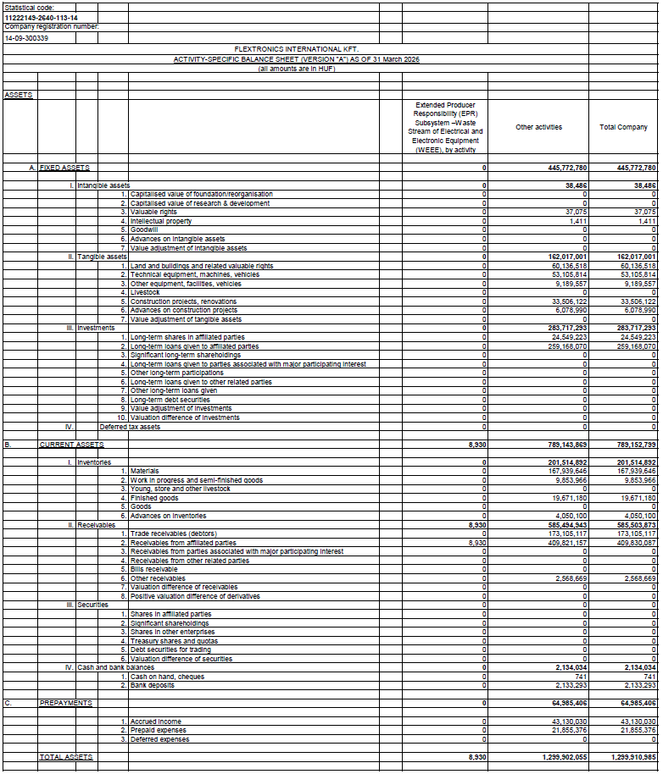

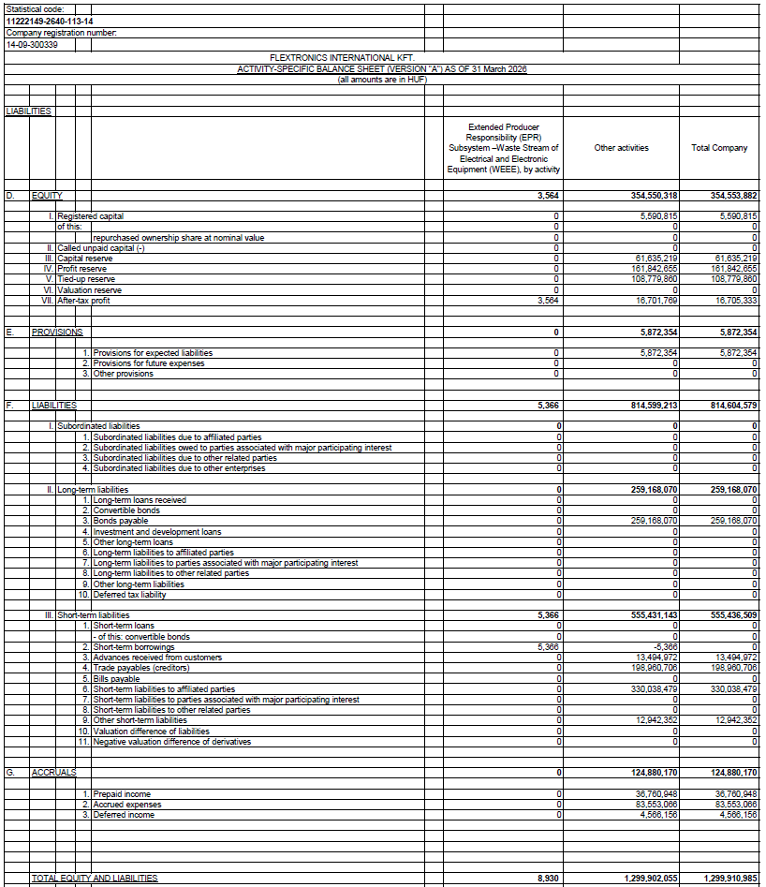

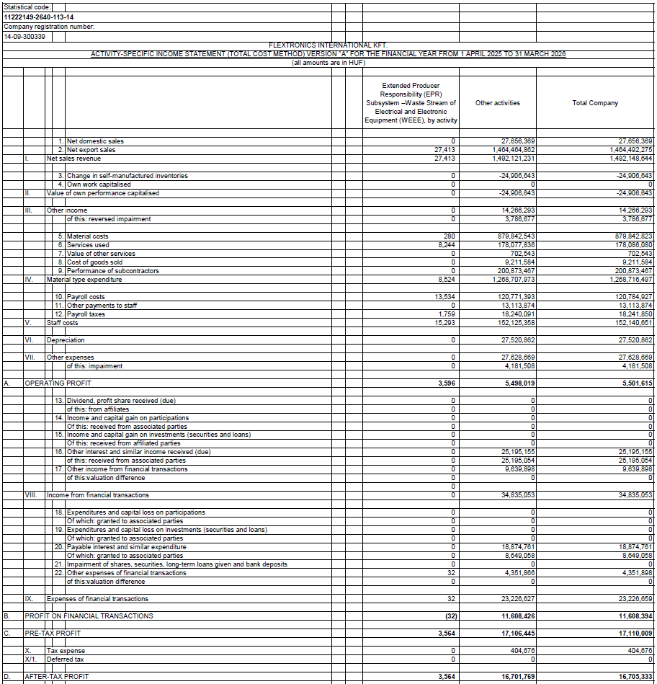

In the opinion of the Company's management, the accounting separation presented in these Supplementary Notes has been prepared in accordance with the applicable legal requirements and the principles set forth in the Company's Accounting Separation Policy and provides a reliable and true and fair view of the assets, financial position and results of the relevant activities.

Tab, 28 July 2026

………………………………………… …………………………………………
Nagy László Christian Pfister
Managing Director Managing Director

